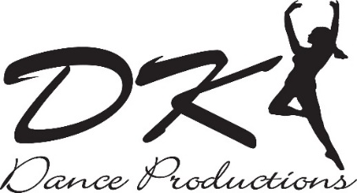
12350 Old Halls Ferry Rd. Florissant, MO 63033
314-921-5800
www.dkdancepro.com

SPARK/AMT Volunteer Application

Name: __________________________________________________________ DOB: ________________________
Address: _________________________________________________________________________________
City: _______________________________ State: ________ Zip: _____________
Home Phone: _________________________ Cell Phone: ________________________________
Email: ________________________________________________________
Profession: __________________________________________________
How did you hear about SPARK/AMT? __________________________________________________________
Relevant past work/ volunteer experience: ____________________________________________________ ___________________________________________________________________________________________________ ___________________________________________________________________________________________________
Qualities that you would bring as a SPARK/AMT volunteer: ___________________________________
______________________________________________________________________________________________________________________________________________________________________________________________________
Contact information for reference:
Name: ___________________________________________
Email or cell phone number: ________________________________________
Relationship: ___________________________________________

